Ford Mustang 2015 - Onwards
800HP / 1000HP Fuel Module

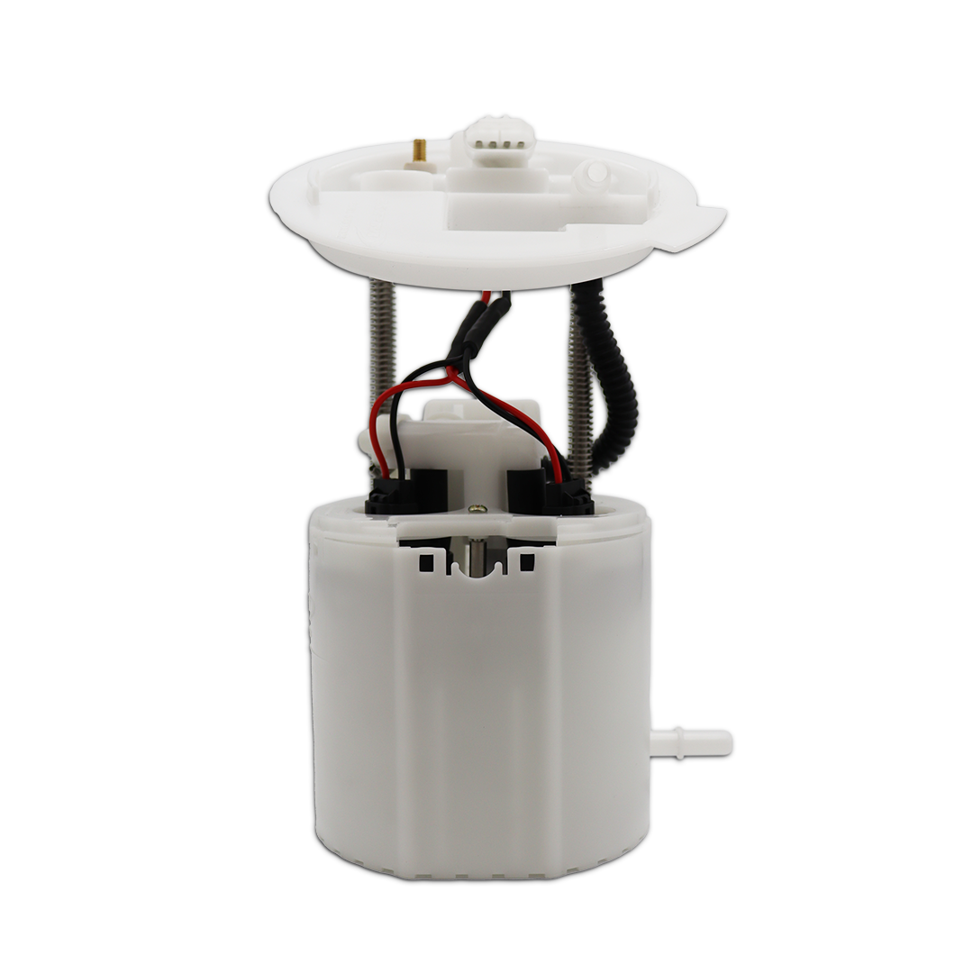

Important! Must Read First
Congratulations on the purchase of a KPM Fuel System for your 2015 - Onwards Mustang GT V8.
To ensure your fuel system is fitted correctly and operates perfectly and reliably, we advise that this kit is fitted by a KPM Fuel Systems Dealer workshop.
If you are unable to access a KPM Fuel Systems Dealer, we strongly recommend a professional and experienced fully qualified technician to install your new fuel system.
Ask your qualified installer to contact KPM Fuel Systems on any aspect not clear in the instructions provided.

Email: enquiries@kpmfuelsystems.com.au

As a wide variety of skills, procedures, special tools, and workshop equipment is needed to install this kit:
- KPM will take NO responsibility or give NO guarantees on the operation of this product for fitment not carried out by a KPM Fuel Systems dealer or experienced qualified technician.
- KPM will take NO responsibility or give NO guarantees on the operation of this product due to not fitting this kit exactly as per the instructions provided.
- Ensure correct workshop safety procedures are carried out in fitment of this kit.
- Please read ALL instructions before commencing fitment.

Guarantee

On satisfaction that ALL instructions have been followed as per this document KPM will warrant this KPM Fuel System against any defects or faults for 12 months from the date of purchase.

Important

This fuel system is engineered to operate perfectly as a complete system, when used with all components only as supplied by KPM Fuel Systems.

Depending on the level of KPM Fuel System you have purchased, included in the kit will be the following;
KPM Fuel Module x1 - Primary (for increased flow and capacity)
- KPM Fuel Systems will take NO responsibility for the operation of this fuel system if any of the components listed are not utilised with this package.
- KPM Fuel Systems will take NO responsibility for the operation of this fuel system if any of the components listed are replaced with a non-KPM approved component.
- KPM will take NO responsibility for the operation of this fuel system if used on a vehicle NOT fully retrofitted for E85 Ethanol or flex fuel.

Note: E85 Ethanol is highly corrosive on many components.

Please be aware that if your car is NOT built for E85 Ethanol from manufacturer, it may be possible that components NOT supplied by KPM Fuel Systems will also need to be replaced or suited for E85 Ethanol. Examples of some possible non-compatible components - are fuel injectors, fuel filters, fuel lines, rubber hoses, fittings etc.

All KPM Fuel System components are 100% ethanol and petrol compatible.

Before Dismantling
- You will need to reduce residual fuel pressure in the fuel system to 0 kPa to enable disconnection of fuel lines.
- You can do this by removing the fuel pump fuse and running the engine until
fuel pressure drops to 0 kPa.
- Disconnect the Battery.

Standard Fuel Module Removal
- Drain the fuel tank.
- Remove the rear seat base to access the fuel module opening on the LH rear seat floor.
- Remove and place to the side the large rubber grommet covering the fuel module.
- Remove the fuel lines from the fuel module (a quick disconnect tool is recommended for disconnecting fuel lines, take extra care in not crimping/ damaging the fuel line on removal). Remove the electrical connectors from the module.
- Remove the retaining ring holding the fuel module to the tank with the correct tool.
- Lift the module from the tank until you can access and remove the internal crossover pipe connector at the base of the canister.
- Carefully lift the module completely from the fuel tank.

Internal Fuel Tank Crossover Hose Fitting Replacement

- Pull the internal crossover hose as far out of the tank opening as possible to access the quick connect straight fitting.
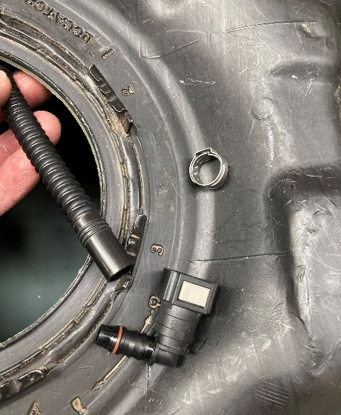
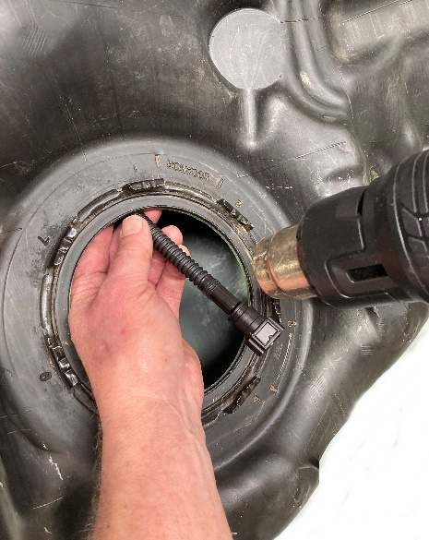
- Using a heat gun, carefully and slowly heat the internal hose at the fitting end to remove the straight factory fitting. BE CAREFUL not to overheat the hose and damage it.

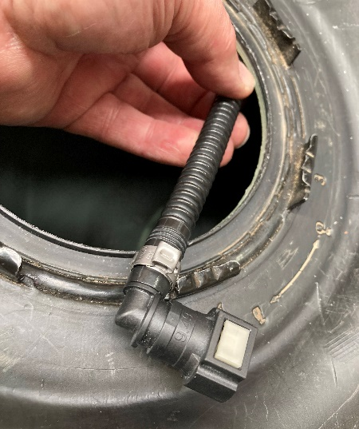
- Fit the new right-angle fitting to the internal fuel hose without tensioning the hose clamp.

- Fit the hose and fitting to the KPM fuel module and estimate the position of fitment in the tank to give the correct orientation of the fitting on the internal hose.
- When you have a relaxed fit between the hose and fitting tighten the clamp to its final position.

KPM Primary Fuel Module Fitment

800HP/1000HP

You will need to remove the fuel sender unit from the standard fuel module for fitment to the upgraded KPM Fuel Module.

- Carefully lower the new fuel module into the tank, taking care not to damage the fuel sender and float mechanism while doing so.
- Ensure that you can access the crossover pipe connector in the fuel tank with plenty of room to reconnect to the base of the canister.
- Ensure the crossover pipe connector clicks fully onto the fuel pump module canister.
- Retention the retaining ring to secure the fuel module into the tank with the correct tool.
  - Ensure module is sitting square and flush on the seal prior to tensioning.
- Refit fuel lines ensuring they have clicked on properly.
  - Take extra care in not crimping/damaging the fuel line on removal or replacement.
- Be sure to check for any fuel leaks on initial start. (Next section).
- Refit the rubber floor grommet and rear seat base.

Engine start up
- Refit the fuel pump fuse.
- Reconnect your battery.
- Ensure you have at least ½ tank of correct clean/fresh fuel.
- Connect a fuel pressure gauge to the supply line at the fuel rail or read your fuel pressure on your scan tool.
- Prime fuel system and start engine.
- Check all fittings at pump and fuel rail for NO leaks.
- Check pressures are within factory specifications.

- Stop engine and relieve fuel pressure.
- Remove fuel pressure gauge and reﬁt fuel line.
- Re-start engine and check for NO leaks.



As these pressures are the base operating pressure in the testing station, they can be used directly into the vehicle’s calibration.

However, as we have found minor variances from vehicle to vehicle, it is recommended to manually check pressures on vehicle when able to do so. Preferably at the fuel rail and use observed pressure, to populate tables in the calibration. Which should be the same or extremely close to testing pressure.

All KPM fuel modules listed have been manufactured and designed to run at the listed pressures at idle and light cruise. They have also been designed to decrease the fuel pressure while applying engine load for increased fuel demand. This is how the system is designed to perform and is absolutely what you will expect to see while logging fuel pressures on road or dyno.

All KPM Fuel Modules are designed to perfectly supply fuel down to a minimum pressure of 350 kPa at full demand for its power rating.
KPM Fuel Systems strongly recommends that you have your engine tune checked by a professional tuning workshop!
Depending on the previous fuel system your vehicle has been tuned to, your car may run differently with the new KPM Fuel System pressure and extra supply.
This can cause rich or lean fuel mixtures and possibly be detrimental to your engine!
It is your responsibility to have your vehicle checked and/or re-tuned by specialist methods to ensure correct fuelling and engine safety and reliability.
It is your responsibility to have your vehicle checked and/or re-tuned by specialist methods to ensure any fault codes in the vehicles electronic management system/s are corrected.

